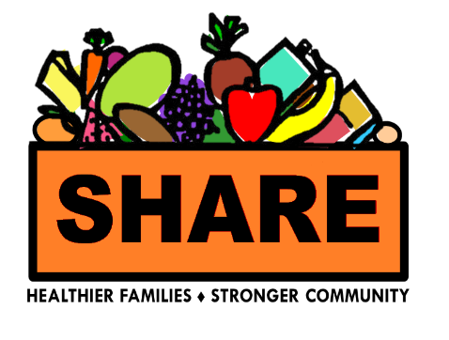


SHARE Food Network Order Form
*Please submit paper orders in Cafeteria by Friday, October 2nd at 12:00 noon*

All menu items are subject to change due to availability.

ITEM | PRICE | QUANTITY | TOTAL
A. Value Package | $31 |  | $
B. After School Snack | $19 |  | $
C. Salmon Special | $29 |  | $
D. Fresh Fruit Box | $24 |  | $
Order Total  1. PAY at a cafeteria register *  2. Attach receipt  3. Drop in SHARE order box |  |  | $

* For orders outside of Frederick Health, and all orders paid with EBT, please leave a callback request at www.frederickhealth.org/SHARE. Call the SHARE hotline at
240-566-7427 for questions or more information. *

Please Initial | I will pick up my order at Frederick Health Village on Saturday, October 17th between 8:30 am - 10:00 am.  - Enter from Monocacy Boulevard at the four-way stop-sign where the Frederick Health sign is located and follow signs for the West Entrance.  - Distribution updates will be emailed on 10/15/2026.
Please Initial | 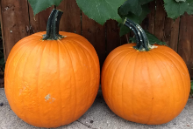  ► I understand that SHARE food orders not picked up by the end of distribution will be donated.

First Name | Last Name | Email | Phone on pickup day
****Please watch your email for a distribution update on 10/15****

